COMP3010: CW1
Introduction:
Investigating recorded network traffic on the 27th of June 2017 from a .pcap file identified a compromised system within the network. The earliest observed sign of suspicious activity occurred at 13:38:32 UTC where the system requested a malicious executable from an external HTTP server which was then proceeded by additional executable downloads, multiple intrusion detection system (IDS) alerts, and a plethora of outbound communications, indicating a multi-stage malware incident.
Investigation Methodology:
The investigation was comprised of Wireshark packet analysis, corroborated by Snort and Suricata alert logs, cryptographic hashing, and external threat intelligence.
Through Wireshark’s DHCP filter, I identified the infected workstation and then by using the HTTP filter I was able to reveal suspicious, their corresponding responses, and subsequent outbound communications and compare them to related IDS alerts. Furthermore, I then recovered the identified malicious executables through Wireshark’s export feature and utilised PowerShell’s ‘Get-FileHash’ command to calculate their SHA-256 hashes.
VirusTotal was then used to investigate discovered URLs and file-hashes to provide additional threat intelligence, supported by historical reporting of a Japanese malspam campaign.
Technical Findings:
Infected System Identification
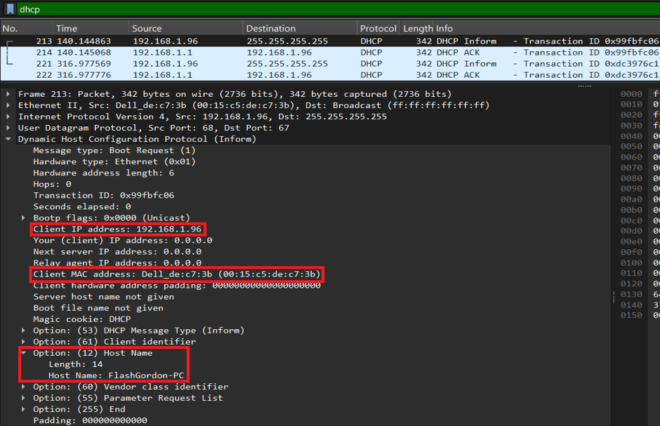
Wireshark packet 213 contains a DHCP Inform message that explicitly discloses the infected system’s network configuration:
The client IP and MAC addresses, and hostname, are highlighted above. The same IP address appears in the suspicious HTTP exchanges and malware-related IDS alerts, which gives reason to link the incident to this workstation.
Initial Suspicious Activity
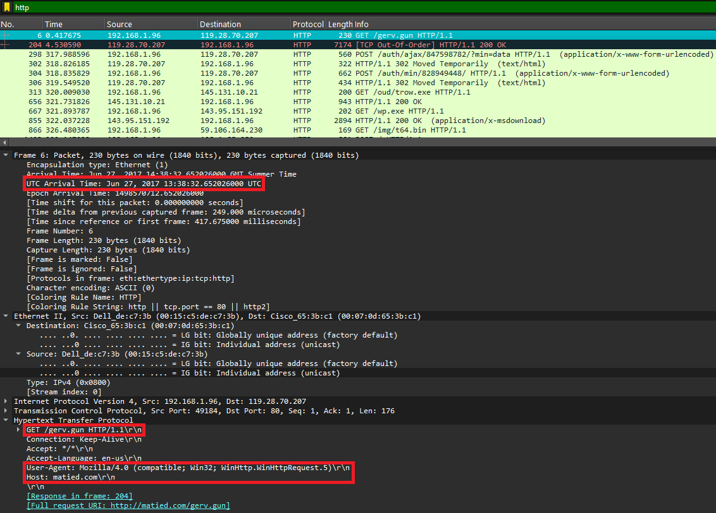
Packet 6 records a HTTP GET request from 192.168.1.96 (the infected system’s IP) to 119.28.70.207 at 13:38:32.652 UTC on the 26th of June 2017. The key findings from the request are highlighted below:
The presence of ‘WinHttp.WinHttpRequest.5’ in the user-agent header would indicate the request was initiated via a program using WinHTTP rather than typical means like a browser. This serves as potential evidence for the source of infection being the previously mentioned Japanese malspam campaign, as WinHTTP exposes an interface accessible to scripting languages like JavaScript.
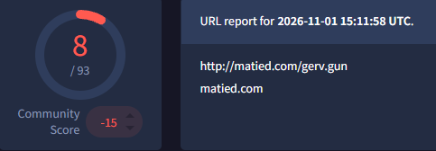
VirusTotal was then utilised to analyse ‘matied.com/gerv.gun’ where I found that 8/93 security vendors had flagged the URL as malicious or threat-related, further proving that this was the point of infection for the system.
Infection Vector
Further investigation into the URL led me to the reporting of a Japanese invoice-themed malspam campaign that sent emails containing ZIP attachments that disguised JavaScript files as regular documents (My Online Security, n.d.). Published analysis connects these scripts to the same ‘matied.com/gerv.gun’ resource we found in our own analysis.
Firefly (2017) identifies ‘2017-547805549-231.pdf.js’ among the campaign’s attachments, whose double extension is likely being used to mislead recipients into believing the file is a PDF. Execution of this script could then initiate the observed WinHTTP download.
However, the original email and its JavaScript attachment were not recovered during my Wireshark analysis and so its involvement remains a highly-supported hypothesis rather than a certain cause for the incident.

Malware Identification
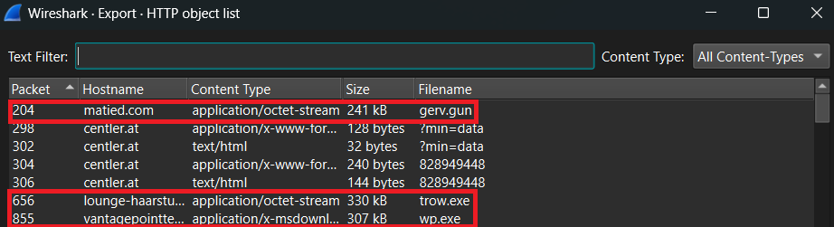
Following the initial download, additional HTTP requests were made approximately five minutes later. In total, three executables were recovered:
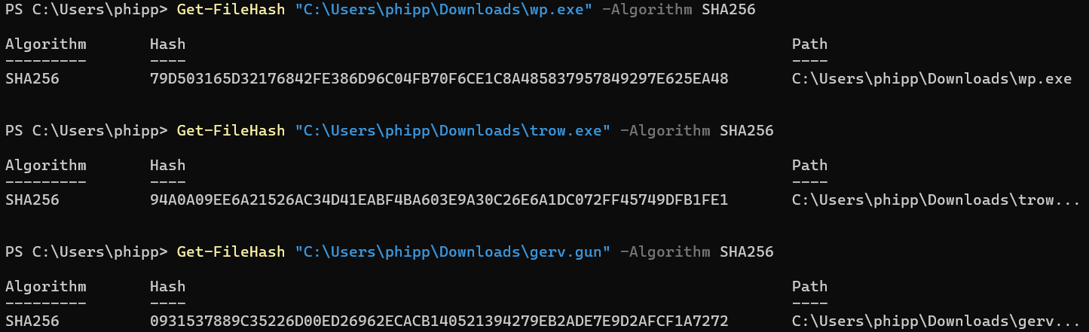
I then calculated their SHA-256 hashes using PowerShell to provide identifiers that could be utilised for further threat-intelligence searches.
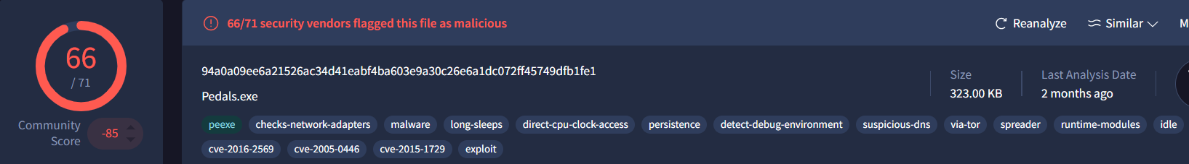
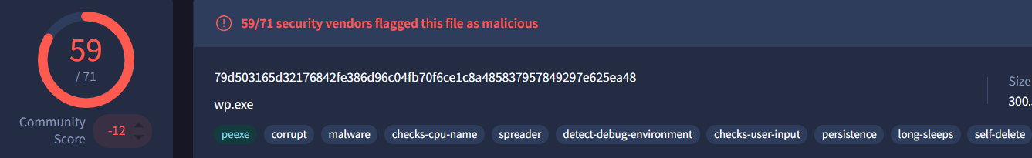
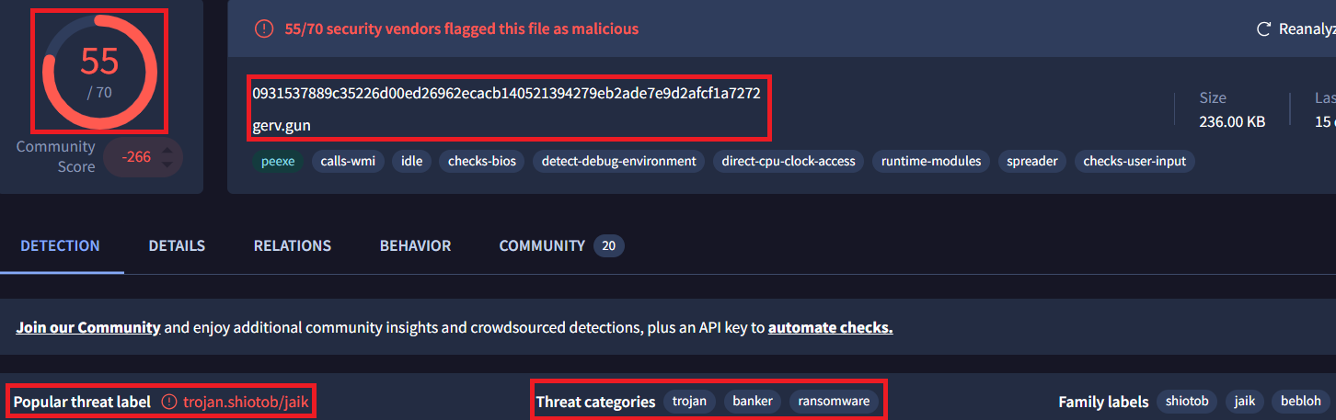
I then used VirusTotal to analyse the recovered file hashes, all of whom were overwhelmingly identified as malicious trojans by most security vendors.

Resulting Malware Activity
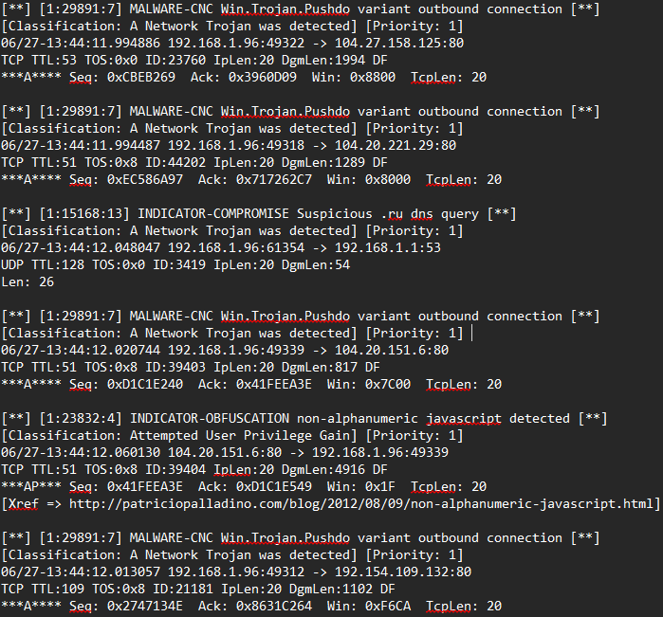
The above classification of the recovered files is further supported by Snort’s detection of a Kazy-associated outbound connection to 143.95.151.192:80 at 13:43:54, followed by numerous Pushdo-related detections under signature 29891. Suricata similarly generated ‘ET TROJAN Backdoor.Win32.Pushdo.s’ Checkin alerts from 192.168.1.96 to external destinations, including 96.82.200.1:80.
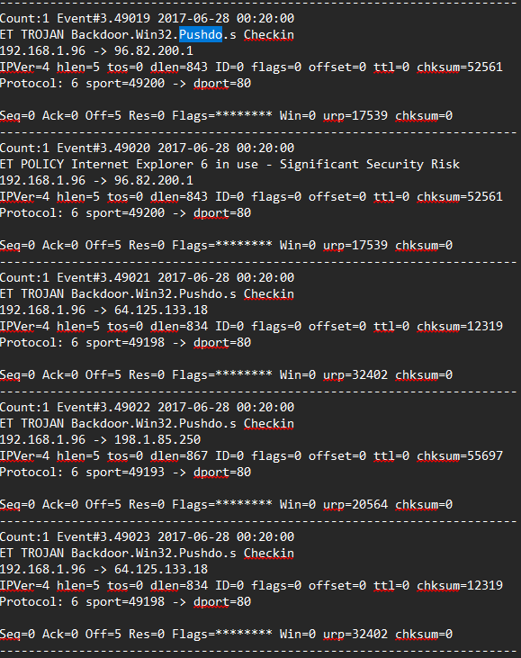
In addition to the IDS alerts, Wireshark also displays numerous HTTP POST requests to various external IPs following the downloads.
The agreement of the two IDSs strongly supports Pushdo-associated command-and-control activity.
Additionally, Snort recorded abnormal outbound SMTP traffic to external servers, which is typically consistent with spam-related activity. This could suggest the malware was attempting to further distribute itself to recipients outside of the network.

Evidence Evaluation:
The identification of the host and malware download sequence is supported by packet-level evidence whilst the cryptographic hashes enable reproducible file identification. Additionally, historical reporting of the malspam campaign and analysis of the recovered executables from VirusTotal provide further corroboration.
However, there are some faults in the evidence. A key instance is that Suricata timestamps differ substantially from the corresponding Snort events and Wireshark analysis, likely due to the alerts being regenrrtated using tcpreplay a couple hours after the infection. However, the content, e.g. source/destination addresses, supplied by the IDS is still accurate. It just means that only Wireshark and Snort could be used to establish an accurate timeline.
Whilst external threat-intelligence did give us a likely culprit for the source of the infection, including the suspected file’s SHA-256 hash (59727ea201d94d471bdbb353b1281cca3c5bebf5305b140a3c017e52a37be702), the file itself was not present in the packet capture and, consequently, cannot be said with certainty that it was the cause of the breach.

Incident Response & Recommendations:
Immediately, the infected system, FlashGordon-PC, should be isolated with its memory, disk images, and network logs preserved, following ISO/IEC 27001:2022 Annex A controls 5.26 and 5.28. Other endpoints should be searched for the recovered file hashes and HTTP, DNS, and SMTP activity should be reviewed to determine the scope of the incident.
The workstation should be rebuilt from a trusted image, with it being patched and verified safe before reconnection to the network. Confirmed malicious indicators should be blocked, and outbound SMTP requests should be restricted to authorised mail relays.
Apply NCSC malware guidance through attachment filtering, script-execution restrictions and endpoint monitoring, supported by CIS Controls v8.1 (8–10, 17). Align escalation, recovery and lessons learned with ISO/IEC 27035-1:2023, ISO/IEC 27001 Annex A 5.24/5.27 and NIST SP 800-61r3. Validate improvements through attachment-blocking and SMTP-control testing.

Conclusion:
FlashGordon-PC showed signs of malicious downloads and Pushdo-associated communications. According to historical readings, a JavaScript file hidden within an email attachment was the likely source of infection, but such file was not recorded within the packet capture. Containment, preservation of evidence, and preventative controls should be the organisation’s top priority.

